RDA E learning Instructions
All online RDA Training that is not tutor led can be found on the RDA E learning site. This includes the “safeguarding for everyone” and “safeguarding for equestrians’ refresher” courses.
How To Access RDA E Learning
- From MyRDA: Home - MyRDA
Step 1) Log in to MyRDA (If you need help creating with this please ask for our MyRDA helpsheet)
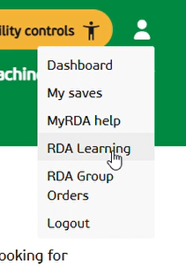
Step 2) Go to the white icon of a person’s head and shoulders in the top right hand corner and hover over it. A drop-down menu will appear. Click on RDA Learning. This will take you directly to the RDA E learning site
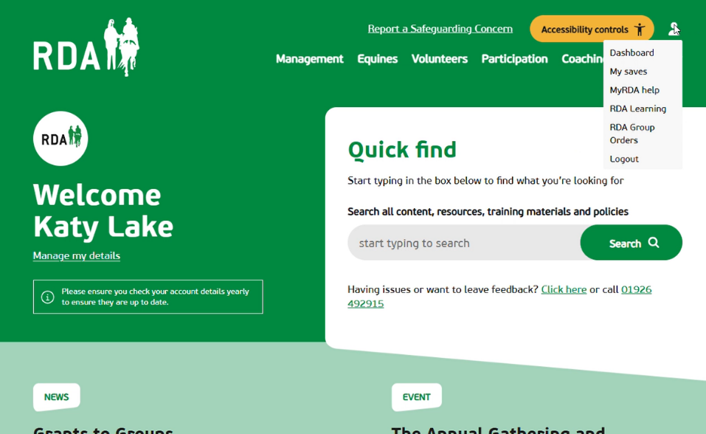

OR
- Through the direct RDA E Learning Website link: RDA Learning – Online training courses for Riding For The Disabled
How To Log In And Sign Up
Please note – MyRDA and E Learning are different websites. If you have a MyRDA account this does not automatically mean you have an E learning account.
If you are trying to enrol onto a course and it is asking you to log in, but your log in details are being rejected, it probably means you do not have an account and will need to create one.
How To Create An Account
Step 1) Go to the task bar at the top of the page and click on “sign-up” (see image below)
Step 2) Follow the sign-up instructions.
- You need to be a member of a group to sign up. So if you are a new volunteer with a group we suggest you use the name of the group you are joining when you sign up.
- You will be asked to make up a username, we suggest that you use your email address to make remembering your credentials easier.
Step 3) You will now have an RDA E learning account and will be able to enrol on the courses you wish to complete.
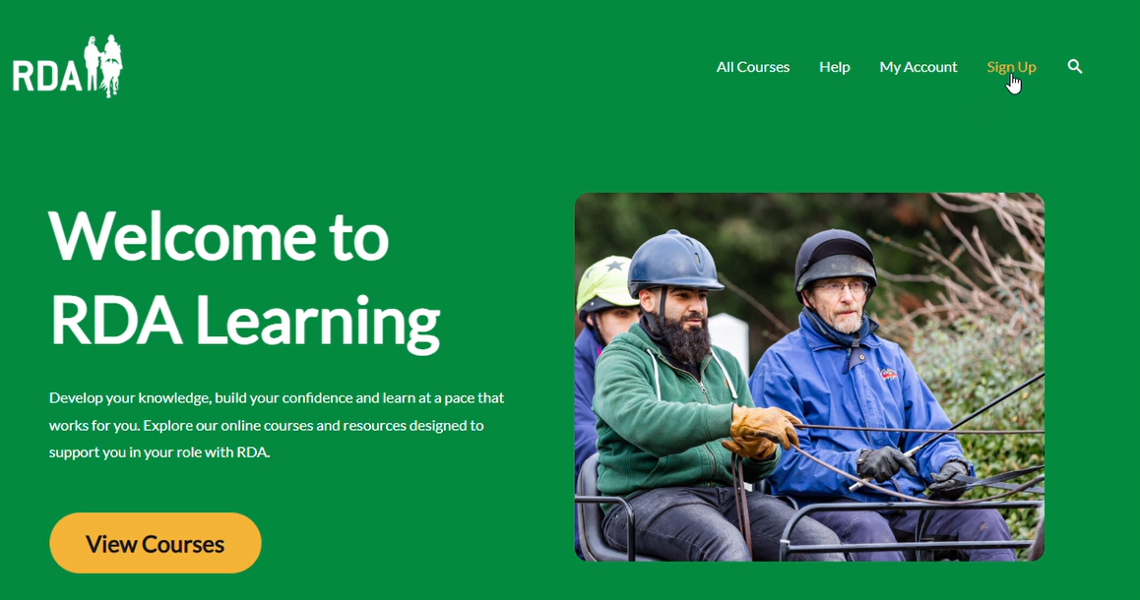

Helpful Tips for knowing if you are on the right website and whether you are logged in
- The home page to RDA E Learning will say “Welcome to RDA Learning” Whereas the home page for MyRDA will say “Welcome (your name)” if you are logged in or “Welcome to MyRDA” if you are not logged in
- In RDA E Learning if you are logged in the “sign up” option on the task bar on the top right of the page will not be shown as an option

If you are still having problems please contact groupsupport@rda.org.uk or ring 01926 492915
Many thanks The RDA Membership Services Team

