Reset Your Password On My-RDA
Step 1: Visit the welcome page at my-rda.org.uk and click log in
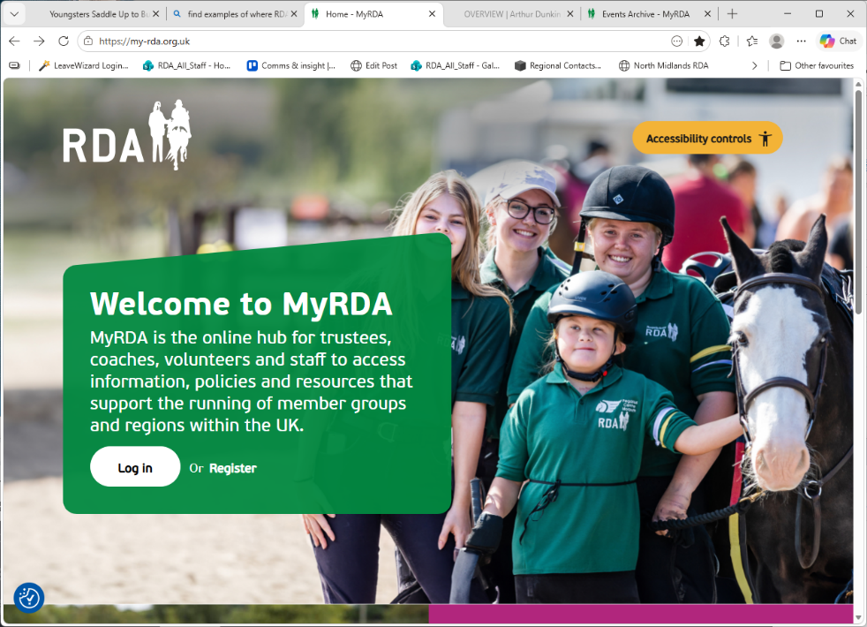
Step 2: Click on Lost Your Password underneath the main log in boxes
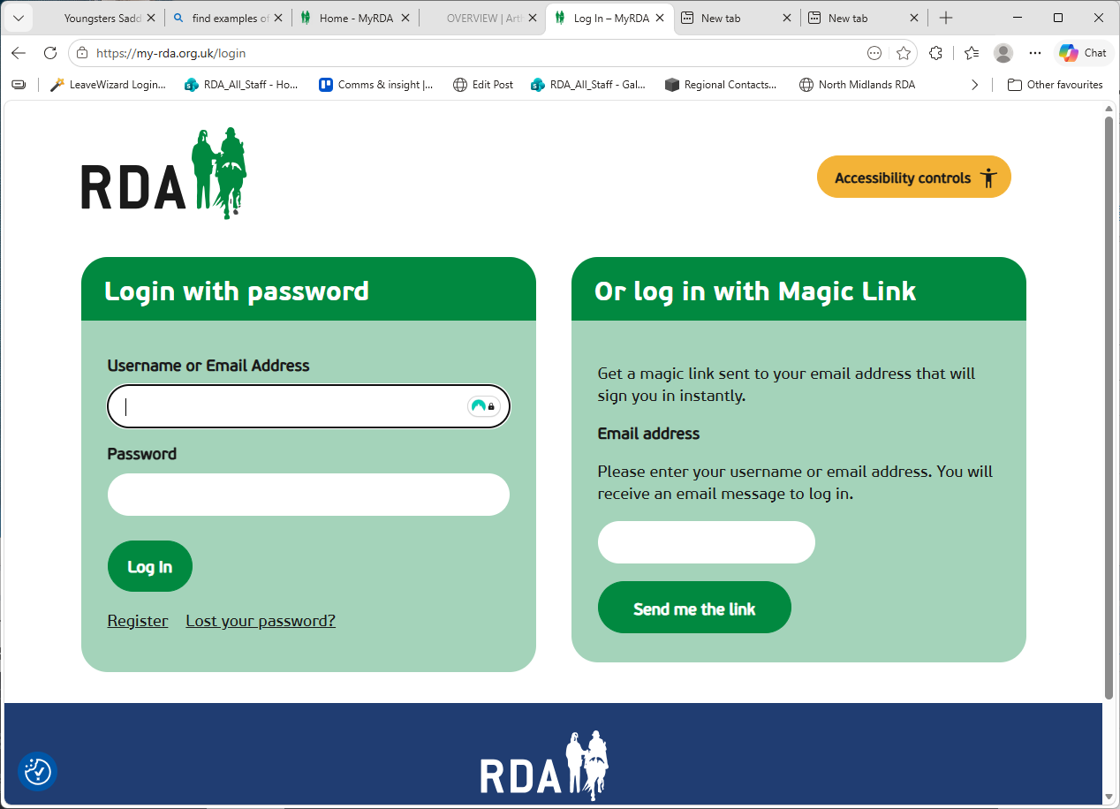

Step 3: You will receive an email from noreply@rda.org.uk, titled [MyRDA] Password Reset. If you cannot see it, please check your junk folder
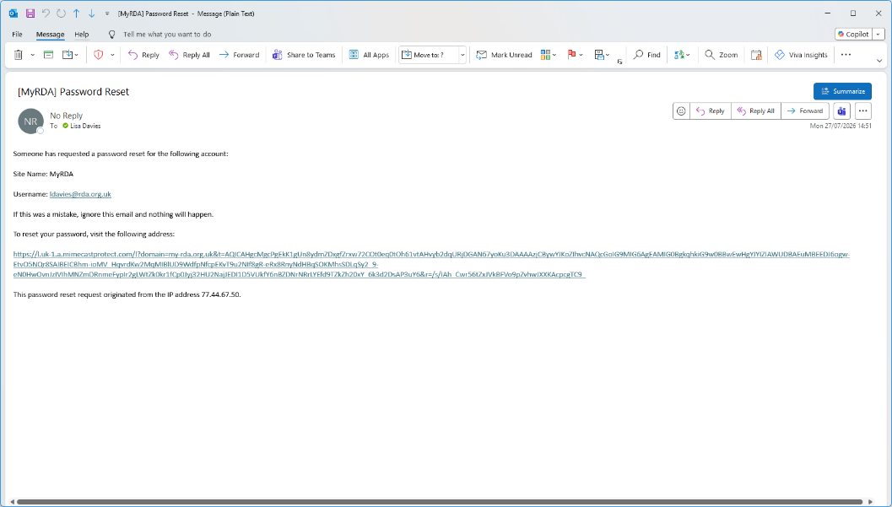
Step 4: Select a new password, enter it in both boxes and hit save password. Return to the main log in page, and you should now be able to log in with your new password.
