Helpful Hints and Tricks for MyRDA

- Less is more: When you are searching for something on MyRDA generally the less words you use the better. For example, if you want to find Volunteer Application Forms searching for “Volunteer Application form” will give you a much better result than “show me the forms volunteers need to fill out to apply to volunteer”
- You can filter your search results to help you find what you are looking for (see image below).
- Documents: you will only see documents such as PDF or Word forms.
- Articles: You will see the page on the website related to your search criteria
- News: You will see announcement pages with exciting news and events
- Training or Event: You will see pages with the details of upcoming training and events you can sign up for events and training on these pages too.
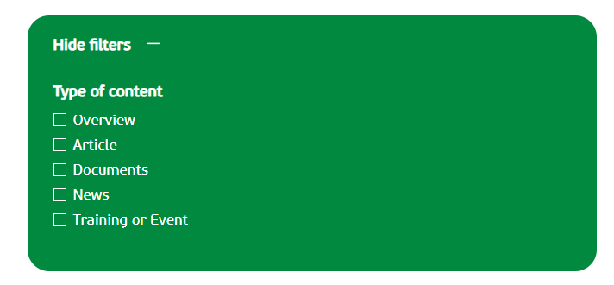
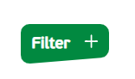

- For pages you visit regularly you can save them to your dashboard for easy access to them. For example, the “Getting more people involved with volunteering” page which houses all the volunteer application forms and reference forms.

How to save a page
Step 1) Go onto the page you want to save
Step 2) Locate the blue heart on the right-hand side of the page and click it. It will go from being a blue heart with a white inner to a blue heart with a blue inner (see images below)

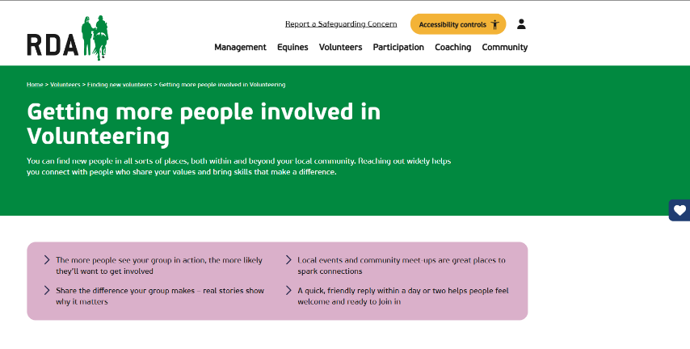



Step 4) Go to your dashboard and under the heading Quick Links you will see the page you have just saved (see image below)
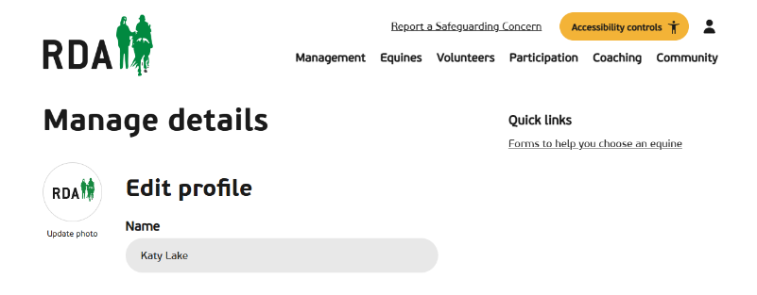
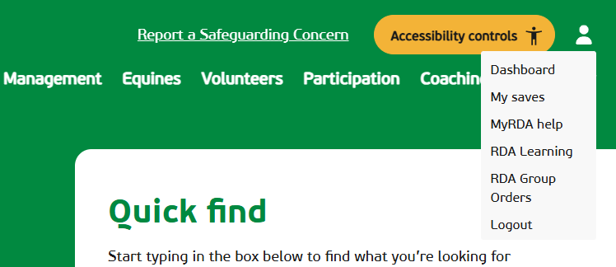

- The Community Tab along the task bar on the top right of MyRDA is a helpful place to find things! Here you can find:
- Training and events – including Tutor Led Safeguarding Courses and Coaching Training Modules
- The Network Newsletter Achieves
- The RDA People Directory – This includes all RDA UK Staff and Volunteers

