RDA South Region
2026 Regional Show
Saturday 17 May 2026 • Berkshire College of Agriculture, Burchetts Green, Maidenhead
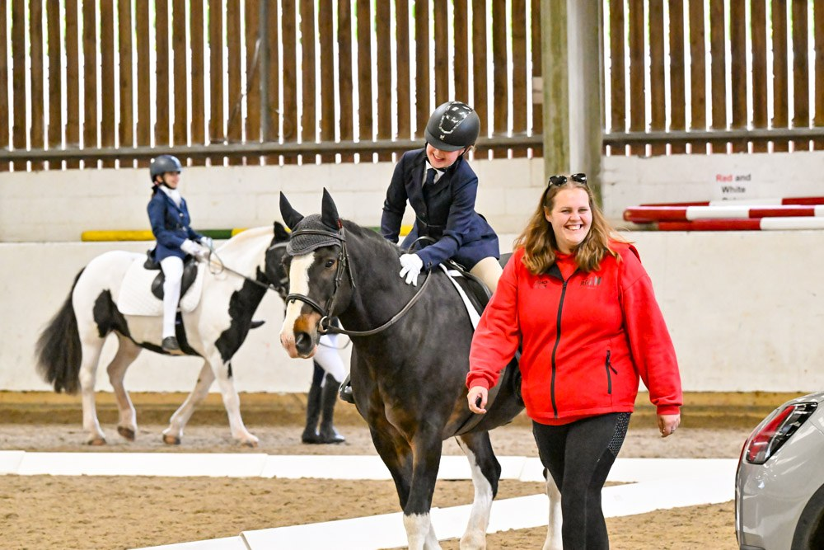
All smiles in the indoor arena

A wonderful day of riding, achievement and smiles
On Saturday 17 May 2026, the RDA South Region gathered at Berkshire College of Agriculture in Burchetts Green for our 2026 Regional Show. Despite a weather forecast that looked decidedly changeable in the days running up to the event, we were once again blessed with good conditions on the day itself — continuing what is fast becoming a happy tradition for our show.
Eight RDA groups from across the South Region came together for a day of dressage and Countryside Challenge competitions, with riders of all ages and grades putting in fantastic performances. There were smiles everywhere — from the competitors themselves to the parents, helpers, volunteers and supporters cheering them on.

The show in numbers
RDA groups represented | 8
Competitors | 50
Horses and ponies | 24
Classes competed in | 25
Total entries (dressage + CC) | 61
Dressage entries | 39
Countryside Challenge entries | 22
The participating groups were: AIM, Abingdon, Bank Farm, Garsington, Newbury, Rossway, South Bucks, Windmill Boldre.

In the indoor dressage arena
The indoor arena hosted 20 entries across nine classes, from the smallest Intro Walk riders to our Grade 6 walk-and-trot tests. Concentration, partnership and pure enjoyment were on show in equal measure.
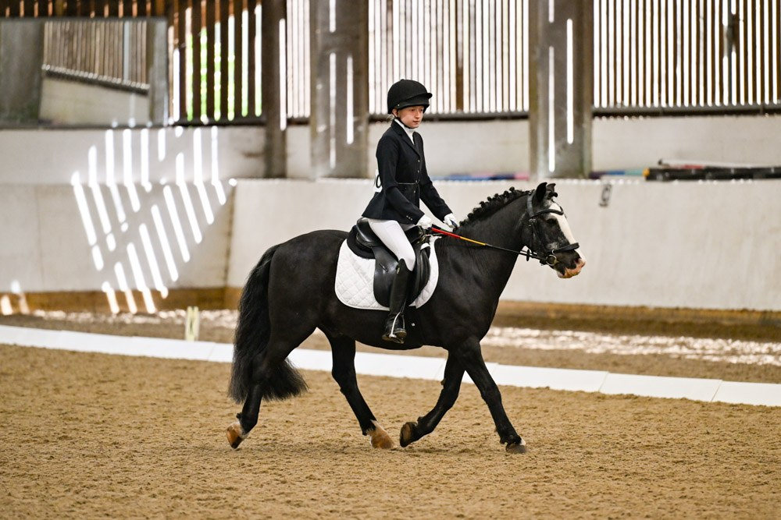
A beautifully composed test in the indoor arena
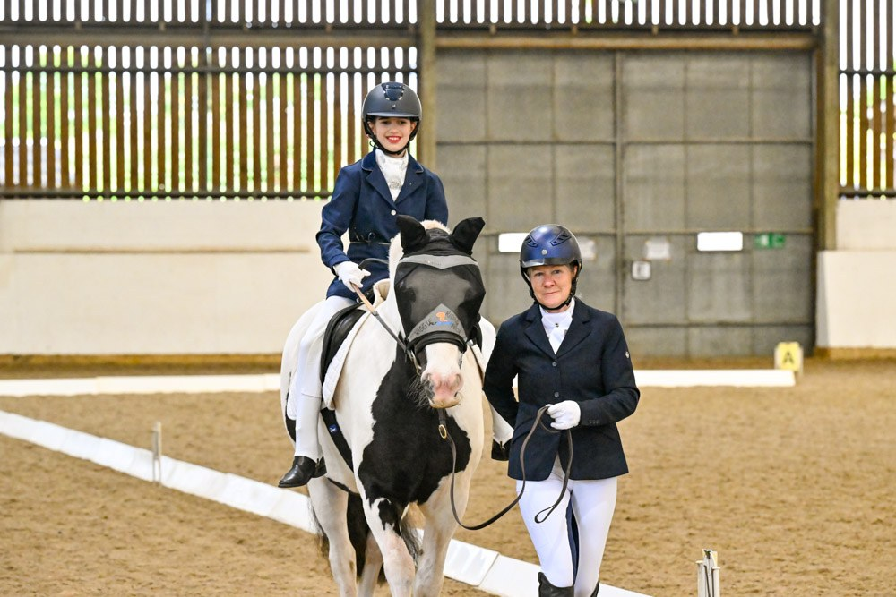  A confident moment in the indoor arena | 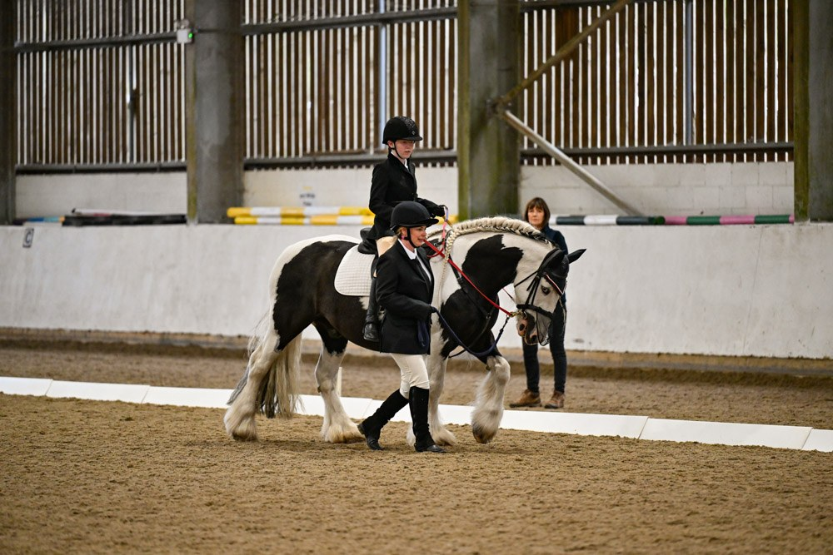  Working in harmony with horse and leader
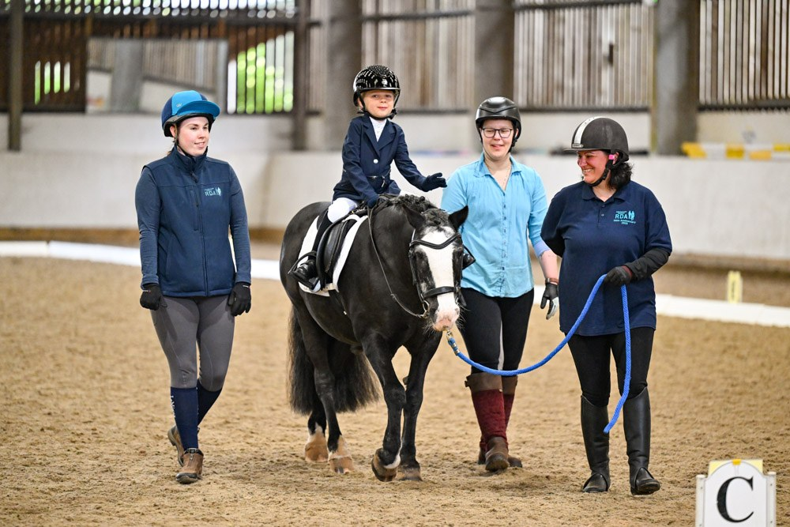
Our youngest riders shone — supported by a wonderful team of helpers

Out in the sunshine: the outdoor dressage arena
The outdoor arena played host to 19 entries across ten classes — including our Grade 7 walk-and-trot and canter classes, our independent tests, and our Open canter class. The sunshine made for picture-perfect conditions.
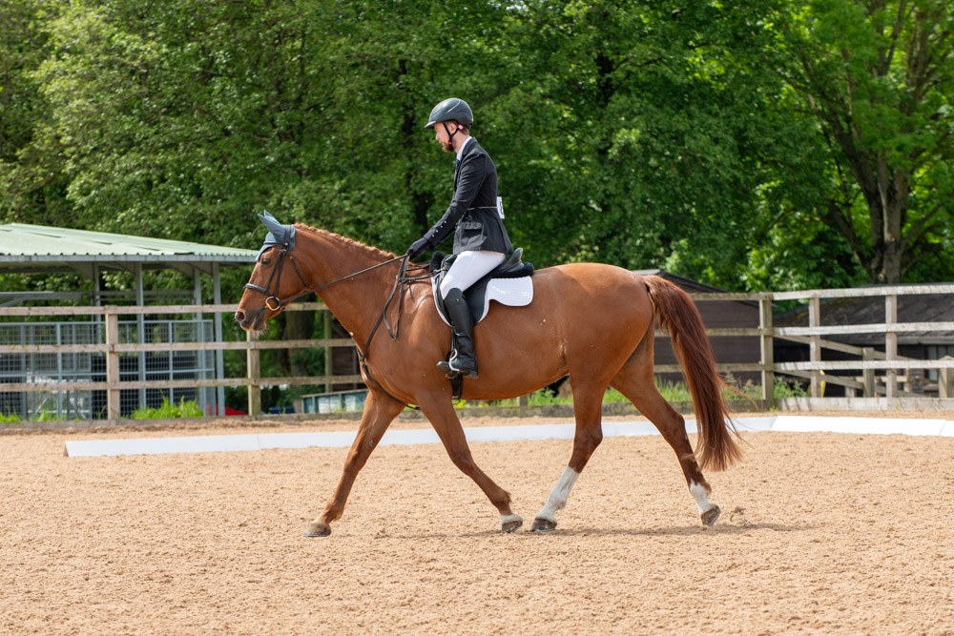
Flowing trot work in the outdoor arena
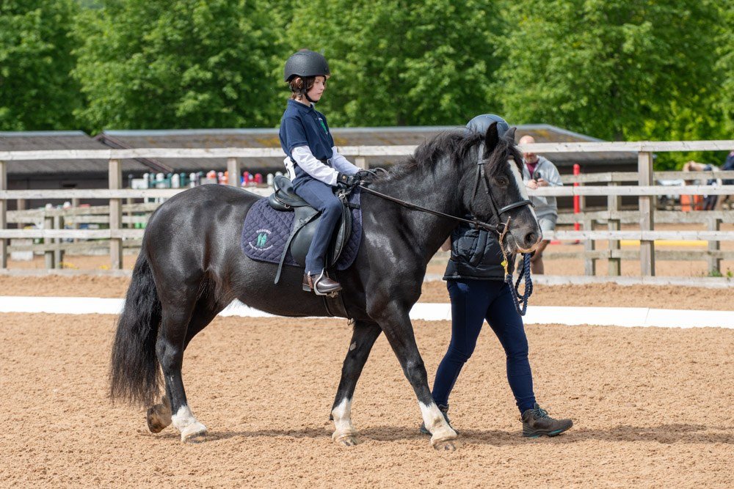  Quiet focus and a willing partner | 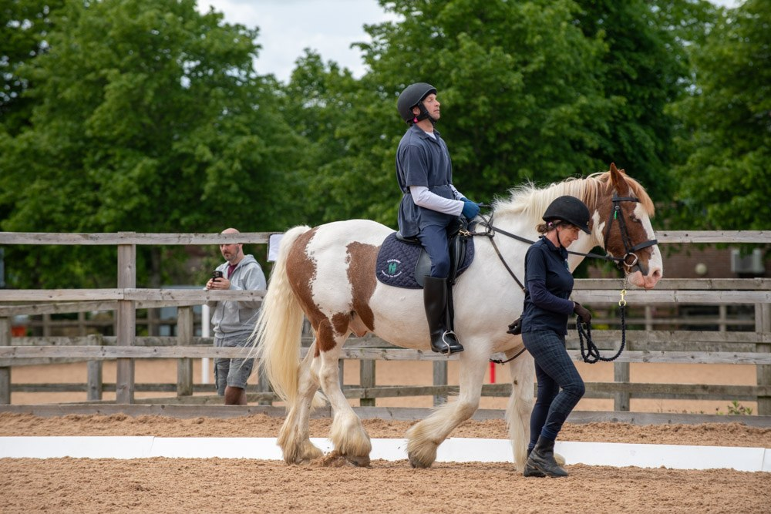  Steady, supported and absolutely on task

Tackling the Countryside Challenge
The Countryside Challenge brought a whole different kind of fun — 22 riders navigating bridges, gates, post boxes, poles and that famously photogenic pig, with cheerful focus and plenty of teamwork. It is a wonderful test of partnership between horse and rider, and the smiles afterwards said it all.
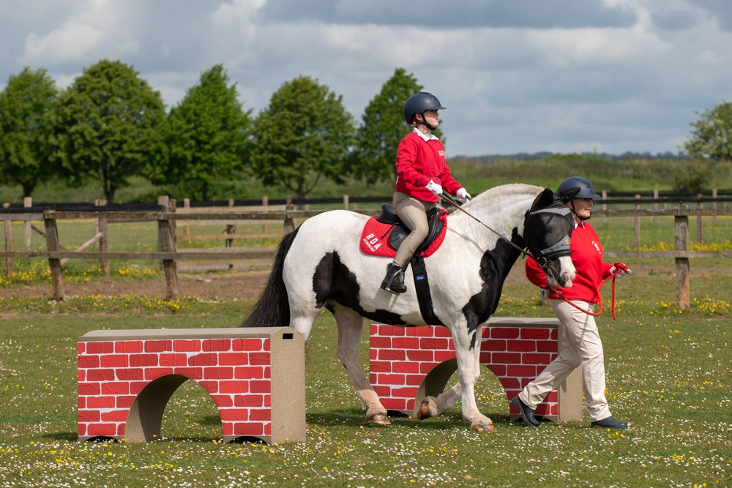
Past the red brick wall in the Countryside Challenge
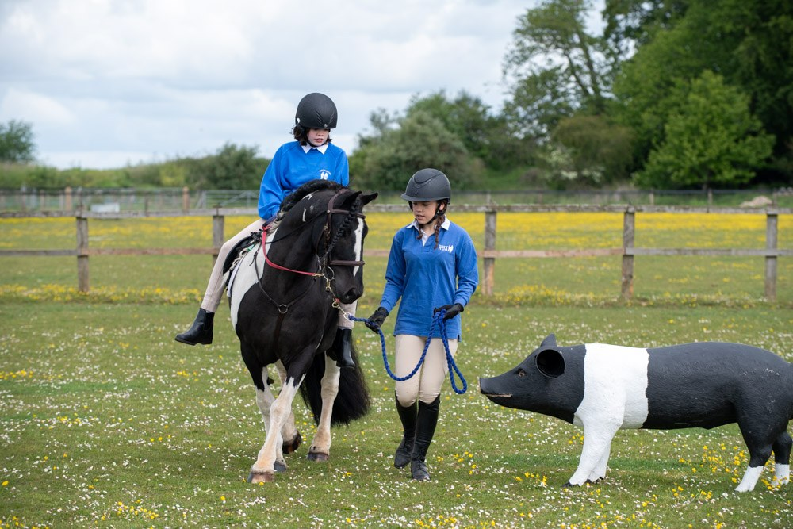  Greeting the pig — always a favourite | 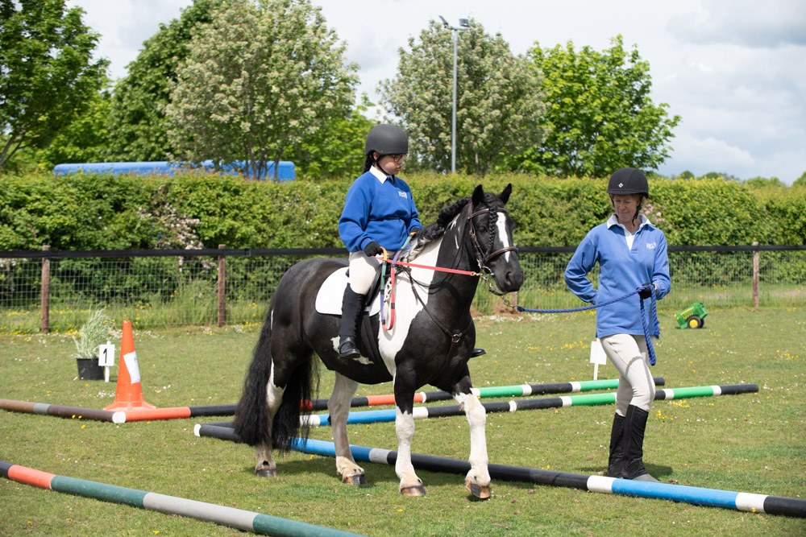  Steering the poles with concentration
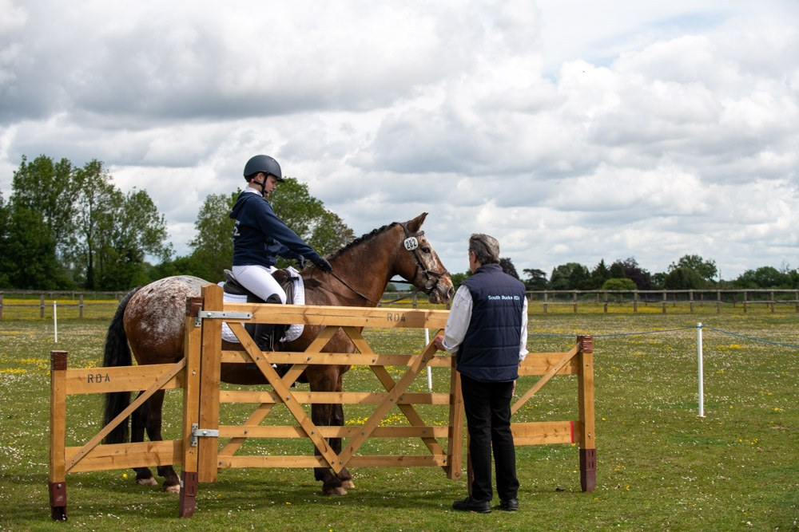  Negotiating the gate, with judge looking on | 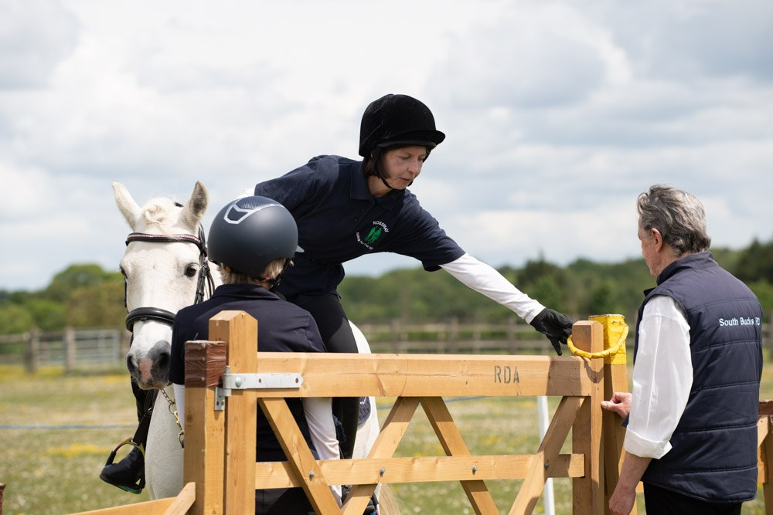  Reaching for the gate latch — a moment of teamwork
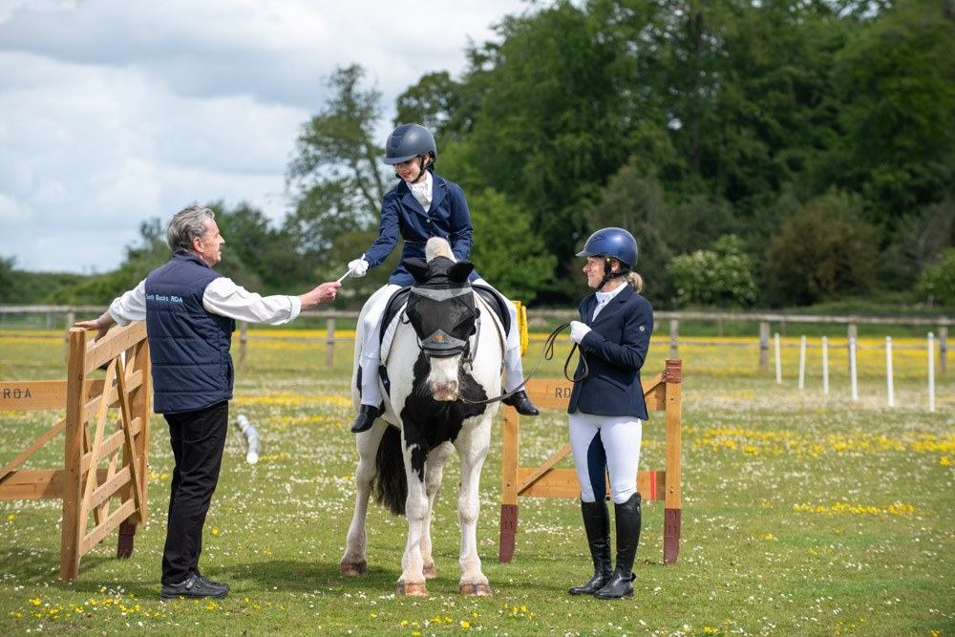
Receiving a well-earned rosette

Great achievements — and on to Hartpury
The standard of riding was a real credit to every group. Riders rose to the occasion with personal bests, beautifully ridden tests and many shining moments out on the Countryside Challenge course. Most exciting of all, a good number of our competitors achieved the scores they needed to qualify for the RDA National Championships at Hartpury in July — a wonderful reward for the hard work, dedication and partnership between rider, horse and helper.
We wish every qualifier the very best of luck at Hartpury — they have earned their place there.

With huge thanks to Project Pony
Every competitor went home with a Regional Show T-shirt, and the winners in each class received a special travel cup — all very generously gifted by our wonderful supporters at Project Pony. Their support means an enormous amount to our riders, who treasure these mementos, and to our region as a whole. Thank you for helping to make the day so memorable.

Capturing the day — Wright Stride Photography
The special moments of the day were captured beautifully by Wright Stride Photography. Their photographs of our riders, horses and the many moments of joy will be cherished by families for years to come. You can see more of their work at www.wrightstride.com.

Thank you
A Regional Show on this scale only happens because of the extraordinary efforts of a great many people, and we are deeply grateful to every one of them:
• To our competitors — for their courage, hard work, and the joy they bring to every test and every challenge.
• To our supporter — Project Pony — for the generosity that makes our prizes and our day possible.
• To our volunteers — judges, writers, stewards, score-keepers, organisers, and all those who give their time so willingly behind the scenes. The show simply does not happen without you.
• And — never to be forgotten — to the wonderful horses and ponies who carried our riders so kindly and patiently throughout the day. They are the true heart of everything we do.
Here's to the riders heading to Hartpury — and to another wonderful Regional Show in 2027.
— RDA South Region —
All photography © Wright Stride Photography • www.wrightstride.com

